## [Why Zoom is shutting down its Chromebook app](https://www.digitaltrends.com/computing/zoom-is-preparing-for-a-new-chat-experience-on-chrome/)

[The Solution to this problem!!!](https://docs.google.com/document/d/19sclik-1B-ZiW6LBRMAL2tF6IY2bjdjqiGsDaGWkbzA/edit?usp=sharing) (this article)

## The NEWS this week:

JUN 22

## 

## [Why Zoom is shutting down its Chromebook app](https://www.digitaltrends.com/computing/zoom-is-preparing-for-a-new-chat-experience-on-chrome/)

“This app will no longer be officially supported after August 2022. Please use the new Zoom for Chrome PWA to join meetings on ChromeOS,” Zoom said in the notice.

NOT TO WORRY!

I went looking for a PWA and found the ZOOM app already installed in my Chrome browser. (see below)

How to RUN an existing Zoom PWA:

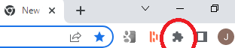

**The Zoom Chrome extension installs an icon next to your Chrome address bar.** If you click the Zoom button, the Chrome extension will open. Sign in to your Zoom account with either the Google sign-in method, email and password, or SSO.

HOW TO ADD ZOOM PWA:

Open your Chrome Browser.

Click the three dots in the top right corner

Select “More Tools”

Select “Extensions”

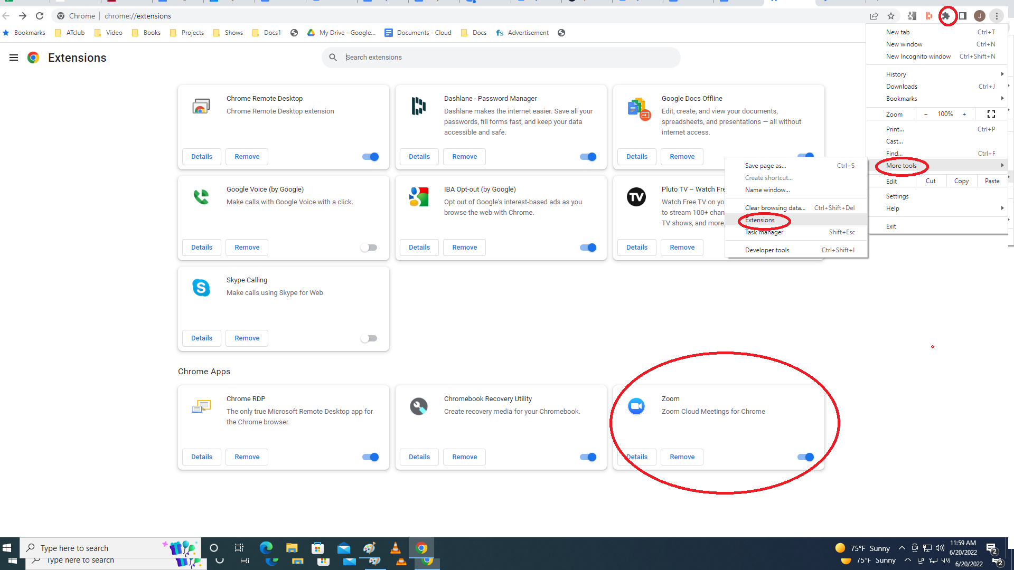

BAM!!!!!!

The zoom extension was already installed on my browser!

You can search/ADD extensions here (top of screen “Search Extensions))

